Name: | Date:
Address: | GP:  GP Clinic Address/phone:
Tel No: | Email:
Occupation: | Date of Birth:
Named Contact (in case of emergency):
Tel no:

SECTION 1: HEALTH ISSUE and MEDICAL HISTORY
Main complaint/what you hope to achieve with acupuncture:

When did it start?
Is it constant/occasional/intermittent?
What aggravates it?
What gives you relief?
In what way does it affect you day to day (e.g. pain intensity/frequency, managing tasks/work/hobbies/mood/sleep etc.)?

Have you discussed this with, or been treated by any of the following?
GP Physiotherapist Osteopath
Chiropractor Acupuncturist Complementary therapist
Fertility clinic Massage or manual therapist
Consultant: Other

Relevant Medical tests
Relevant Medical Diagnosis
Previous surgery or treatments

List Medications
Health Supplements?

Do you have any other current (or previous) significant illnesses?

SECTION 2: MEDICAL AND SAFETY: Please tick ALL that apply:
- Blood Pressure: High Low Normal
- Clotting/Bleeding: Blood thinning medication?
Haemophilia or blood clotting disorder?
- Heart: Heart Condition (state diagnosis)
Pacemaker?
- Neurological history: Spinal injury , Head injury , Epilepsy ,
Any other diagnosed neurological problem?
- Headaches , migraines
- Infectious disease: Hep A , Hep B , HIV ,
Other transmittable infection
- Possibility of Covid-19 infection? yes no
- History of Cancer
- Allergies (list) Possibility of pregnancy
- Upcoming medical appointments , or surgery ?
- Is there anything else you think we should know about?

SECTION 3: PAIN symptoms (hand written copies only)

1. If you can, mark on the diagram where you experience pain.
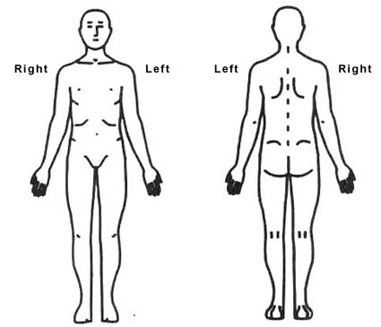

2. If you can, mark your typical pain intensity on the following scales:
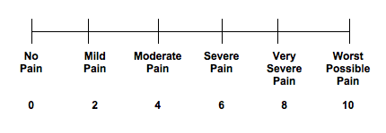
SECTION 4: General health (Chinese medicine)
Select any of the following that may have experienced recently, rating from 0 (never) to 5 (most severe or frequent):

Gan
Irritability/frustration Depression or low mood
Anxiety or stress Emotional eating
Red/Dry/Itchy eyes Headaches
Migraines Dizziness
Feeling lump in throat Feeling pain under ribcage
Muscle spasms Neck/shoulder tension
Feel like sighing Painful periods/PMS

Xin
Feeling like palpitations Chest pain
Insomnia/sleep issues Restlessness/agitation
Vivid dreams Lack of joy in life
Forgetful Aversion to heat

Shen
Bladder infections Frequent urination
Wake to urinate Lack of bladder control
Night sweats/hot flashes Feeling cold easily
Hearing problems Tinnitus
Ankle swelling Low back pain
Painful/weak knees Dark/scanty urine
Thirst (prefers cold) Thirst (prefers warm drinks)

Fei Fever/chills
Dry cough Productive cough
Nasal discharge/drip Sinus infection
Nasal congestion Sore throat
Skin rash/itch Allergies/asthma
Shortness of breath Poor immune system
Pi
Issues triggered with certain foods (list):
Feeling of heaviness/tiredness in the body
Difficulty getting up in the mornings
Fatigue after eating Water retention
Bruises easily Hemorrhoids
Poor appetite Craving sweets
Poor digestion Nausea
Bloating/gas Constipation
Alternating constipation/loose stool Loose stools
Intestinal pain/cramping Heartburn
Overweight Aversion to cold
Sweat easily Overthinking
Difficulty concentration/brain ‘fog’ Yeast infections

Is there anything else that might be relevant?

Other lifestyle notes:
- How do you keep active?
- What is your daily energy like from 1-10?
- diet,
- relaxation
- alcohol
- tobacco
- Another other comments:
- menstrual cycle (e.g. regular/irregular/other issues):

What will be the main benefit in your life when you recover from or learn to gain control of your health issue?

Your statement of consent:
- I confirm that the information I have provided is accurate to the best of my knowledge, and that I consent to the use of this information as described in the Data Privacy Notice (summary).
- I have received and read the information about acupuncture, possible side effects and safety procedures under COVID-19
- I understand the fees and the cancellation policy of £20 for less than 24 hours notice.
- I consent to treatment, and I understand that I can ask my practitioner anything regarding my treatments, expectations and goals.
Signed: Date :
You have finished! Thank you for your patience in completing this form. We hope that you enjoy your first treatment.

Data Privacy Notice (summary): As a new client of Belfast Community Acupuncture we need to advise you how we will be using your personal information in order to comply data protection (GDPR 2018). Belfast Community Acupuncture will collect and process your personal information to allow us to contact you and to plan and review your treatments. We will only use your personal information for the purpose for which it was collected. We will not share your information with anyone else unless it is with your written permission or there is a legal or ethical duty for us to do so. Under Covid-19 we are expected to document extra information, which is protected by the same data laws. In the event of a Covid-19 incident we may be required to pass on your contact details for the purpose of contact tracing. You can find further details on the collection and processing of personal information and the rights you have in relation to your personal information in our Data Protection and Confidentiality Policy on our website at: www.belfastcommunityacupuncture.com; hard copies on request.

Therapist Notes (TCM /Clinical Opinion/Treatment Given/Feedback/etc.)
………………………………………………………………………………………………………………………………………………………………………………………………………...

